**PROJECT REPORT**

**MEASURING SUCCESS IN TALENT MANAGEMENT**

1 INTRODUCTION

* 1. **Overview**

Measuring success in talent management involves assessing various aspects of an

Organization’s workforce to ensure alignment with business goals and objectives.

It typically includes evaluating recruitment processes, employee development , performance management, and retention strategies. The ultimate goal is to have a skilled, motivated, and engaged workforce that contributes effectively to the organization’s success.

* 1. **Purpose**
* Improve Decision -Making: Provide data-driven insights for making informed decisions related to talent acquisition, training, and development.
* Enhance Employee Engagement: Understand how talent management practices impact employee engagement and job satisfaction.
* Evaluate Performance: Assess how well the organization is performing in terms of hiring, retaining, and nurturing talent.
* Strategic Alignment: Determine if talent management practices align with the overall business strategy and goals.

1. **Problem Definition & Design Thinking** 
   1. **Empathy map**

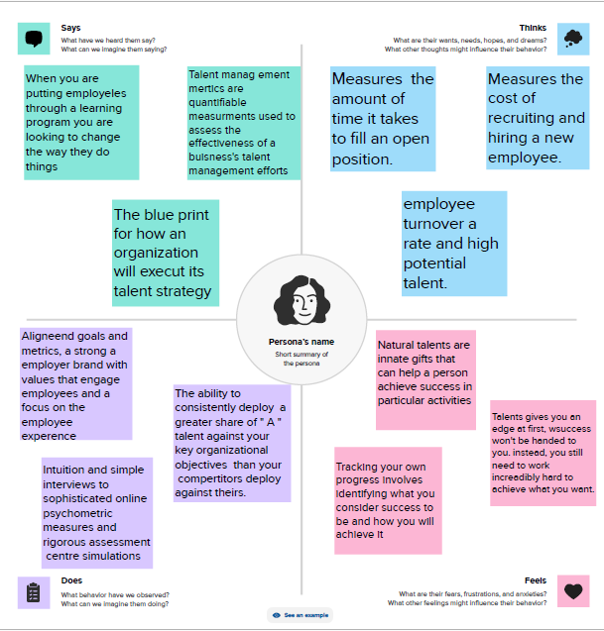

2.2**. BRAINSTROMING MAP :**

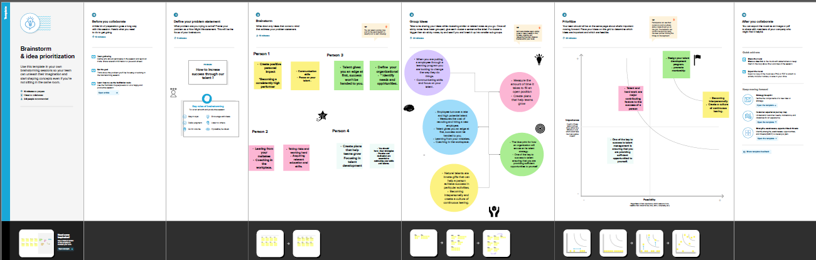

3. **DASHBOARD** :

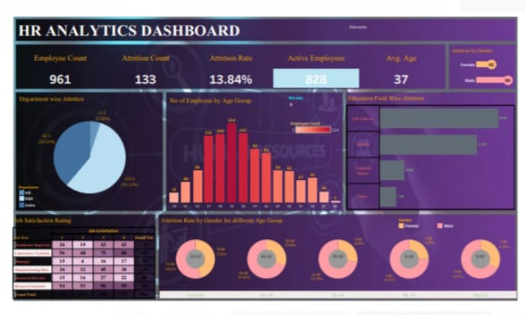

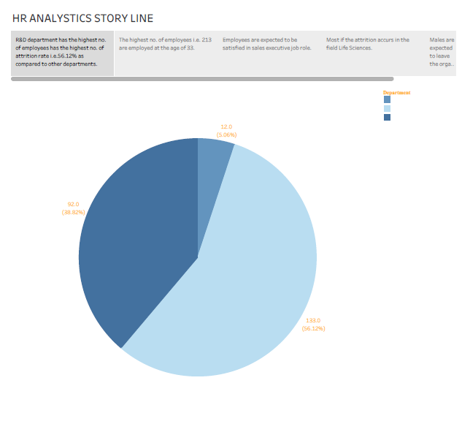4 STORY  
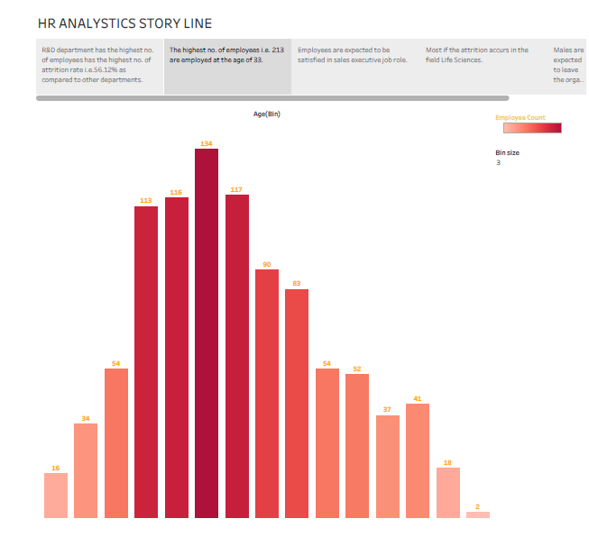

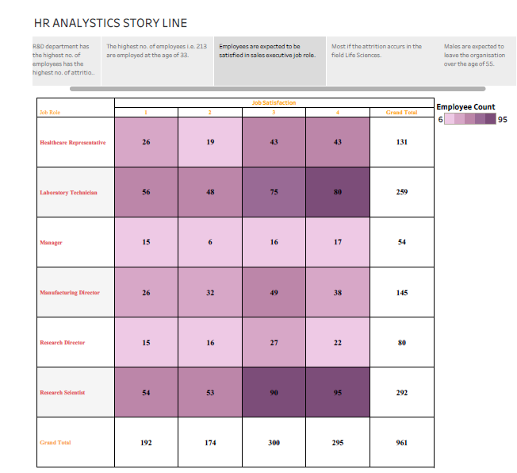

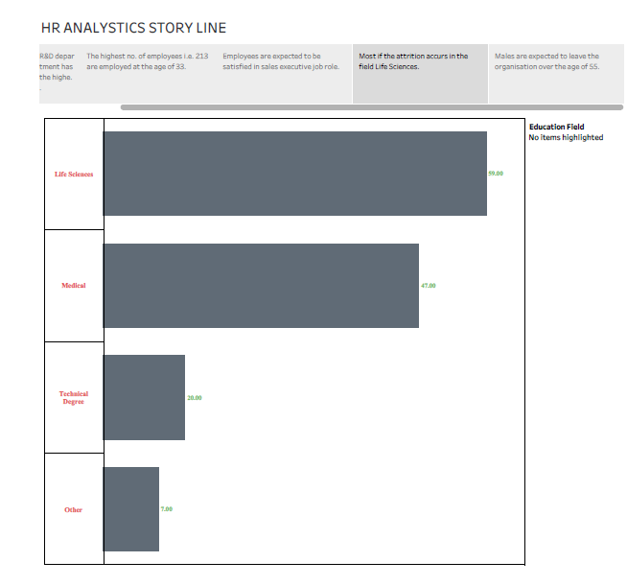

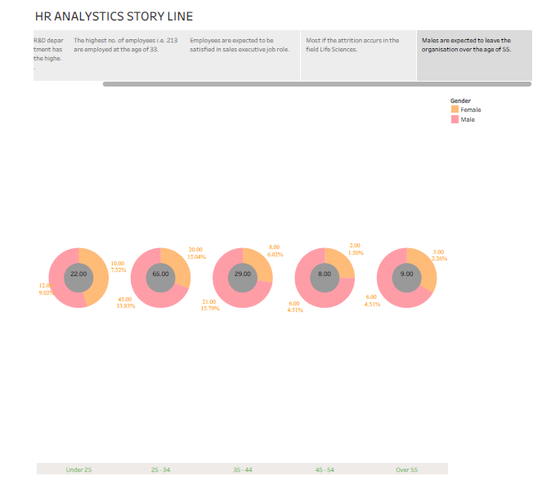

5 **Advantages and disadvantages**

**5.1 Advantages**

* Strategic Alignment: It helps align talent management strategies with overall business goals, ensuring that the organization’s workforce supports its strategic objectives.
* Data-Driven Decisions: Measurement provides data that organizations can analyze to make informed decisions about recruitment, training and employee development, leading to more effective talent strategies.
* Improved Performance: By evaluating employee’s skills and performance, talent management metrices can identify areas for improvement, enabling targeted training and development programs.
* Retention: monitoring talent metrics helps in identifying high-potential employees and addressing their needs, reducing turnover rates and retaining key talent within the organization.
  1. **Disadvantages**
* One major challenge is determining the most appropriate metrics to gauge the effectiveness of talent management strategies.
* Relying solely on quantitative data, such, as employee turnover rates or revenue growth, might overlook qualiltative aspects like employee satisfaction, creativity, or long-term potential.
* Additionally, the metrics chosen can sometimes incentivize short-term gains at the expense of sustainable talent development.
* It’s crucial to strike a balance and consider both quantitative and qualitative factors to get a comprehensive view of talent management success.

6 **Conclusion**

Measuring success in talent management is a multifaceted process that goes beyond more quantitative metrices. It involves aligning individual and organizational goals, fostering a positive work culture, and continuously adapting strategies to meet evolving business needs. Effective talent management embraces a holistic approach that considers employee engagement, skill development, diversity and inclusion, and overall workplace satisfaction. By integration qualitative and quantitative measures, organizations can gain a comprehensive understanding of their talent management efforts and make informed decisions to nurture their workforce and achieve long-term success.

7 **Future Scope**

* Skill Development and Upskilling: Tracking employee’s progress in acquiring new skills and knowledge.
* Employee Engagement: Assessing the level of commitment and enthusiasm employees have towards their work.
* Diversity and Inclusion: Measuring efforts and outcomes related to diversity, equity, and inclusion initiatives.
* Innovation and Creativity: Evaluating employee’s contributions to innovation and creative problem-solving.
* Adaptability: Gauging how well employees adapt to change, especially in the face of technological advancements.

**Submitted By**

**S.Akshitha**

**R.Thangaselvi**

**I.Deviparipoorani**

**V.Utchimahali**

**THANK YOU!!!**